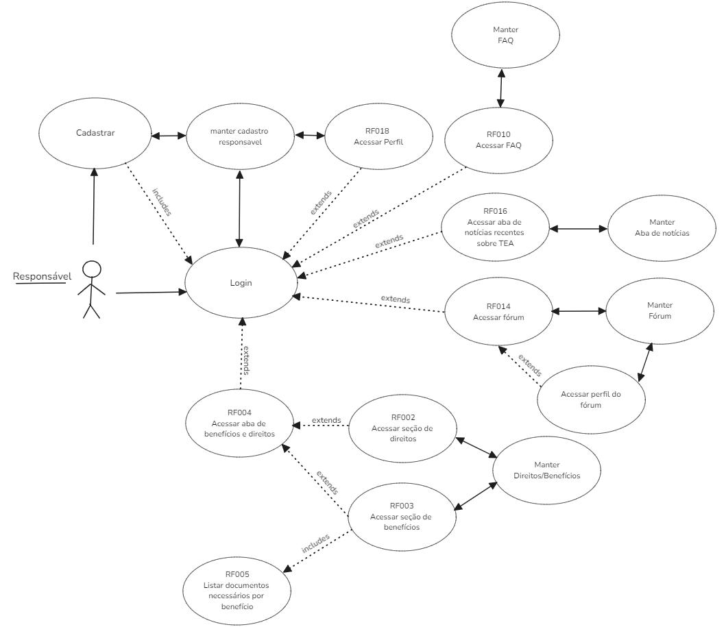

Link do diagrama: https://excalidraw.com/#json=Cqvu8I5-t9ufTxUbWZZLy,TBHIQBDqBpKIZGMIqh3R6Q